Predicting Student’s Academic Performance Using Machine Learning

Abstract— Machine learning, a subset of artificial intelligence, is transforming education by predicting student academic performance. This innovative approach uses historical academic data, attendance, demographics, and more to identify patterns and trends beyond human analysis. Predictive models enable early interventions, personalized learning experiences, and efficient resource allocation. However, ethical concerns and the importance of human touch in education must be considered. This abstract introduces the significance and methodology of using machine learning to enhance learning outcomes, emphasizing its potential to revolutionize education. It highlights the exploration of promises, challenges, and ethical implications in this burgeoning field, ultimately aiming to create a more personalized, data-driven, and effective educational experience in our technology-driven world.
Keywords— Machine Learning, Academic Performance, Predictive Models, Personalized Learning.

Introduction
In today's rapidly evolving educational landscape, the quest for enhancing student academic performance is relentless. Institutions and educators are increasingly turning to cutting-edge technologies like machine learning to unlock the hidden potential within student data. The primary objective of this project is to develop a predictive model that can accurately forecast a student's academic performance based on a multitude of relevant factors, including their background, study habits, motivation, and socio-economic status. Predicting student academic performance is not merely an academic exercise; it's a pivotal tool that can pave the way for personalized learning experiences and early interventions, ultimately bridging the achievement gap. By harnessing the capabilities of machine learning and data analytics, we aim to empower educators, institutions, and policymakers with insights that can revolutionize the way education is delivered. The potential benefits of this endeavor are multifaceted. It allows for the creation of tailored learning plans, ensuring that each student receives the support and resources they need to succeed. Struggling students can be identified in advance, and targeted interventions can be initiated to prevent setbacks and foster their growth. Furthermore, a comprehensive understanding of the factors influencing academic performance can lead to more equitable and inclusive educational practices, reducing disparities among students from diverse backgrounds. This project will leverage machine learning algorithms and data analytics techniques to scrutinize vast amounts of student data, seeking patterns, relationships, and trends that are often elusive to human observation. However, the transformative power of machine learning comes with an array of considerations, including ethical concerns and the preservation of the essential human element in education. In the subsequent sections, we will delve into the methodologies, applications, and challenges of using machine learning to predict student academic performance. We will explore how this innovative approach is empowering educational stakeholders to make informed decisions that can redefine the future of education while ensuring that the human touch in education remains integral. Our journey will shed light on the burgeoning field of predicting student academic performance using machine learning, uncovering its potential, challenges, and ethical implications, ultimately aiming to create a more personalized, data-driven, and effective educational experience.

LITERATURE REVIEW
This literature review encompasses several key studies in the field of educational data mining, each aiming to harness data-driven techniques to improve educational outcomes. Carlos Márquez and Cristóbal Romero's 2018 research applies data mining to predict school failure and dropout among middle-school students, employing various methods to enhance predictive accuracy. Pimpa Cheewaprakobkit's 2019 study focuses on identifying factors affecting academic achievement, utilizing the WEKA data mining tool to predict undergraduate students' performance, with Decision Tree emerging as a highly accurate classifier. S. Kotsiantis and K. Patriarcheas, in their 2019 study, propose an online ensemble of classifiers to predict student performance in distance education, enhancing classification accuracy. Mr. M. N. Quadri's 2019 work delves into using the decision tree technique to predict college student dropouts based on academic performance, offering a valuable tool for intervention by teachers and management. Additionally, Cristóbal Romero and Sebastián Ventura's 2020 paper presents a comprehensive overview of the field of educational data mining, discussing its interdisciplinary nature, applications, and future research directions. These studies collectively exemplify the growing significance of data-driven approaches in addressing educational challenges and improving student outcomes.

DATA DESCRIPTION
The dataset encompasses educational information gathered through a learning management system called Kalboard 360, utilizing the experience API (xAPI) to monitor and track student activities and progress. It comprises records from 480 students, detailing 16 features categorized into demographics, academic backgrounds, and behavioral patterns. Demographic details encompass gender and nationality, with 305 males and 175 females. Nationalities vary, with a majority from Kuwait and Jordan. Academic background features like educational stage, grade level, and section, highlight the diverse educational settings of students. Behavioral attributes include actions such as class participation (raising hand), accessing resources, involvement in discussion groups, and parental engagement in surveys and school satisfaction. The dataset includes data from two semesters, each containing information on school attendance based on absence days. Additionally, parental participation in the educational process is captured through survey responses and school satisfaction. The students' performance is categorized into three levels based on their total grades: Low-Level (0-69), Middle-Level (70-89), and High-Level (90-100). In summary, the dataset encapsulates a comprehensive set of features delineating student demographics, academic endeavors, behavioral engagements, parental involvement, and academic performance, facilitating insights into various facets of the educational process.

METHODOLOGY
This research project focuses on predicting student dropout indicators using data mining techniques. The methodology is structured into four distinct phases. It commences with data gathering, where a dataset is obtained from La Wigan National High School Guidance Office, encompassing student grades, demographic information, and academic performance records. Subsequently, data preprocessing is conducted to prepare the dataset for data mining algorithms. This phase involves addressing missing data, translating values into numerical variables, and selecting only relevant attributes while eliminating insignificant ones. The subsequent stages involve feature selection and data transformation, where relevant features are identified and data is normalized to ensure uniform scales. Following this, the project delves into model selection, training, validation, optimization, and testing. Machine learning models are chosen, trained, validated through cross-validation techniques, optimized through hyperparameter tuning, and ultimately tested on new data to assess their predictive capabilities. This comprehensive methodology guides the research, ultimately aiming to enhance the understanding of student dropout indicators and contribute to proactive interventions in educational institutions.

DATA PREPROCESSING
The dataset underwent crucial preprocessing steps to ready it for analysis. Initially, duplicates were eliminated to preserve data integrity and avoid potential biases in subsequent analyses. Subsequently, the 'Class' variable, representing the target outcome, was excluded from preprocessing considerations. Categorical attributes, such as 'Gender,' 'NationalITy,' 'PlaceofBirth,' 'StageID,' 'GradeID,' 'SectionID,' 'Topic,' 'Semester,' 'Relation,' 'ParentAnsweringSurvey,' 'ParentschoolSatisfaction,' and 'StudentAbsenceDays,' were converted into numerical formats using methods like one-hot encoding, facilitating their integration into machine learning models. Missing data in 'raisedhands,' 'VisITedResources,' 'AnnouncementsView,' and 'Discussion' were handled through imputation using mean or median values to ensure dataset completeness. Additionally, numerical attribute scaling normalized 'raisedhands,' 'VisITedResources,' 'AnnouncementsView,' and 'Discussion,' enabling fair contribution from each attribute during model training. Rigorous data consistency checks post-preprocessing confirmed the dataset's readiness for subsequent modeling endeavors.It suggests that after performing Recursive Feature Elimination with Cross-Validation (RFECV) using a machine learning technique, the optimal number of features selected is 9. The chosen features are:
1. `raisedhands`
2. `VisITedResources`
3. `AnnouncementsView`
4. `Discussion`
5. `gender_M`
6. `NationalITy_Jordan`
7. `Relation_Mum`
8. `ParentAnsweringSurvey_Yes`
9. `StudentAbsenceDays_Under-7`
These features, extracted via RFECV, are considered the most significant or influential for a predictive model or analysis, implying that they contribute the most to the model's performance or accuracy.

ALGORITHMS USED
The provided Python code showcases the utilization of diverse machine learning algorithms for predicting students' academic performance. It demonstrates the implementation and evaluation of six distinct algorithms: Logistic Regression, Random Forest Classifier, Gaussian Naive Bayes, Support Vector Machine (SVM), k-Nearest Neighbors (KNN), and XGBoost. Logistic Regression constructs a linear relationship between input features and the categorical outcome, Random Forest creates an ensemble of decision trees for robust predictions, Gaussian Naive Bayes assumes independence among predictors, SVM finds an optimal hyperplane for classification, KNN makes predictions based on nearby data points, and XGBoost sequentially builds weak learners for efficient boosting. These algorithms vary in their methodologies, strengths, and applicability, providing diverse approaches to address classification tasks. The code exemplifies their application in predicting students' academic performance based on features within the dataset. Each algorithm has unique traits influencing its effectiveness, making their selection contingent on the dataset's characteristics and specific problem requirements.

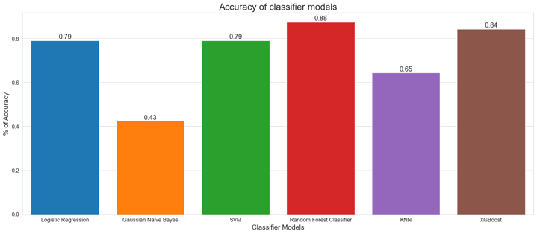
Based on the above graph, Random Forest Classifier has a greater accuracy than others. So we are using Random Forest Classifier for our classification.

RESULTS
Based on the analysis, we found the important features which influences the classification algorithm.
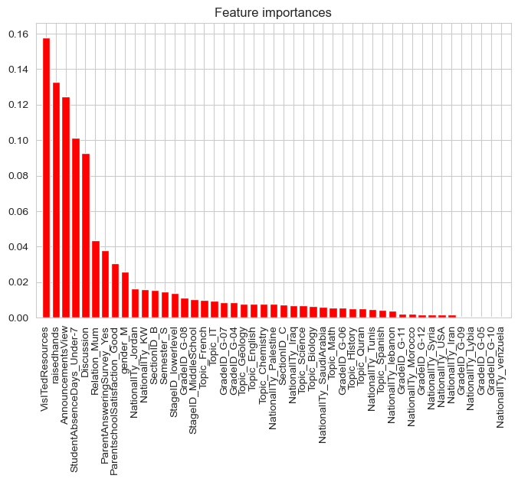
The findings derived from this analysis underscore the profound influence of lifestyle on academic achievement, emphasizing the critical necessity to institute initiatives promoting healthy living. Additionally, it illuminates several other variables that wield substantial influence on academic performance, including stress levels, obesity, family size, and the marital status of parents. Surprisingly, factors traditionally presumed to significantly impact academic success, such as gender, academic level, average household income, and parents’ educational qualifications, did not demonstrate a direct correlation with academic performance. Moreover, the study unveils the efficacy of machine learning algorithms in identifying and prioritizing factors that contribute to overall academic outcomes. This presents an invaluable resource for educational institutions worldwide, enabling a deeper understanding of individual student performance determinants and facilitating the formulation of tailored frameworks geared towards enhancing the quality of education.
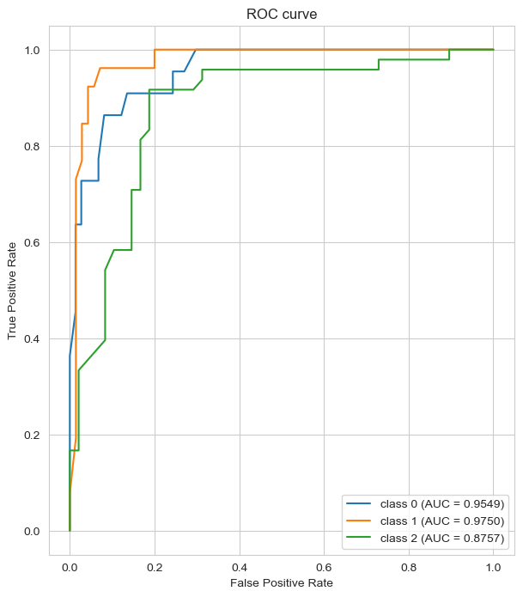
The ROC curve evaluation is pivotal for assessing the classification model's performance across multiple classes. Here, distinctive ROC curves highlight varying predictive accuracies for each class. Class 0 demonstrates exceptional discrimination, boasting an AUC of 0.9549, implying superior performance in identifying its instances. With an AUC of 0.9750, Class 1 surpasses others, showcasing outstanding predictive prowess. However, Class 2 displays a slightly diminished AUC of 0.8757, indicating reduced accuracy in distinguishing its instances. In summary, the model excels in differentiating Class 0 and Class 1 instances, but its performance is slightly less robust for Class 2. These findings elucidate the model's efficacy in accurately classifying diverse instances, providing insights for potential enhancements, particularly for refining predictions in Class 2.

FUTURE SCOPE
The future scope involves leveraging advanced algorithms like neural networks or ensemble methods to refine predictive models, enhancing accuracy across all classes. Additionally, exploring feature engineering techniques to identify and integrate more influential attributes could enrich model performance. Integrating real-time data streams and adopting adaptive learning approaches can create dynamic models capable of adjusting to evolving academic environments. Furthermore, expanding this study's scope to diverse demographics and educational systems globally would yield comprehensive insights, aiding in tailoring interventions for individual student needs, thereby fostering more inclusive and effective educational frameworks.

